**Experiment No. 6**

**Title:** Installation and Configuration of Virtual Machine with Guest OS

**Objective:**

To set up and configure a virtual machine (VM) with a guest operating system (OS) on a macOS environment using VirtualBox or VMware Fusion.

**Tools used:**

- VirtualBox or VMware Fusion

- macOS

Prerequisite:

- Downloaded VirtualBox or VMware Fusion installer

- Knowledge of the guest OS ISO file to be installed

Theory:

Virtual machines enable the creation of an isolated environment within an existing operating system. This environment functions like a physical computer and allows users to install and run different operating systems simultaneously.

**Steps to Install and Configure a VM with Guest OS:**

**Step 1:** Download and Install VirtualBox or VMware Fusion

- Visit the respective websites for VirtualBox or VMware Fusion and download the macOS version.

- Double-click the installer and follow the on-screen instructions to install the software.

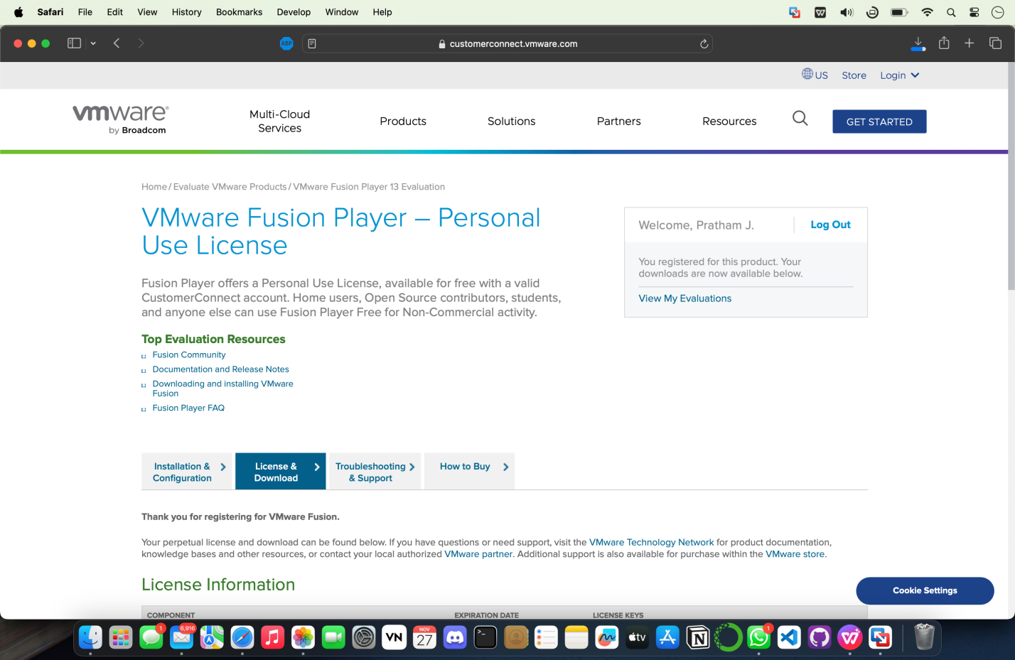

**Step 2:** Obtain Guest OS ISO

- Download the ISO file for the guest OS you intend to install on the VM. we will install windows 11 on macos, get ISO file from <https://www.microsoft.com/software-download/windows11>

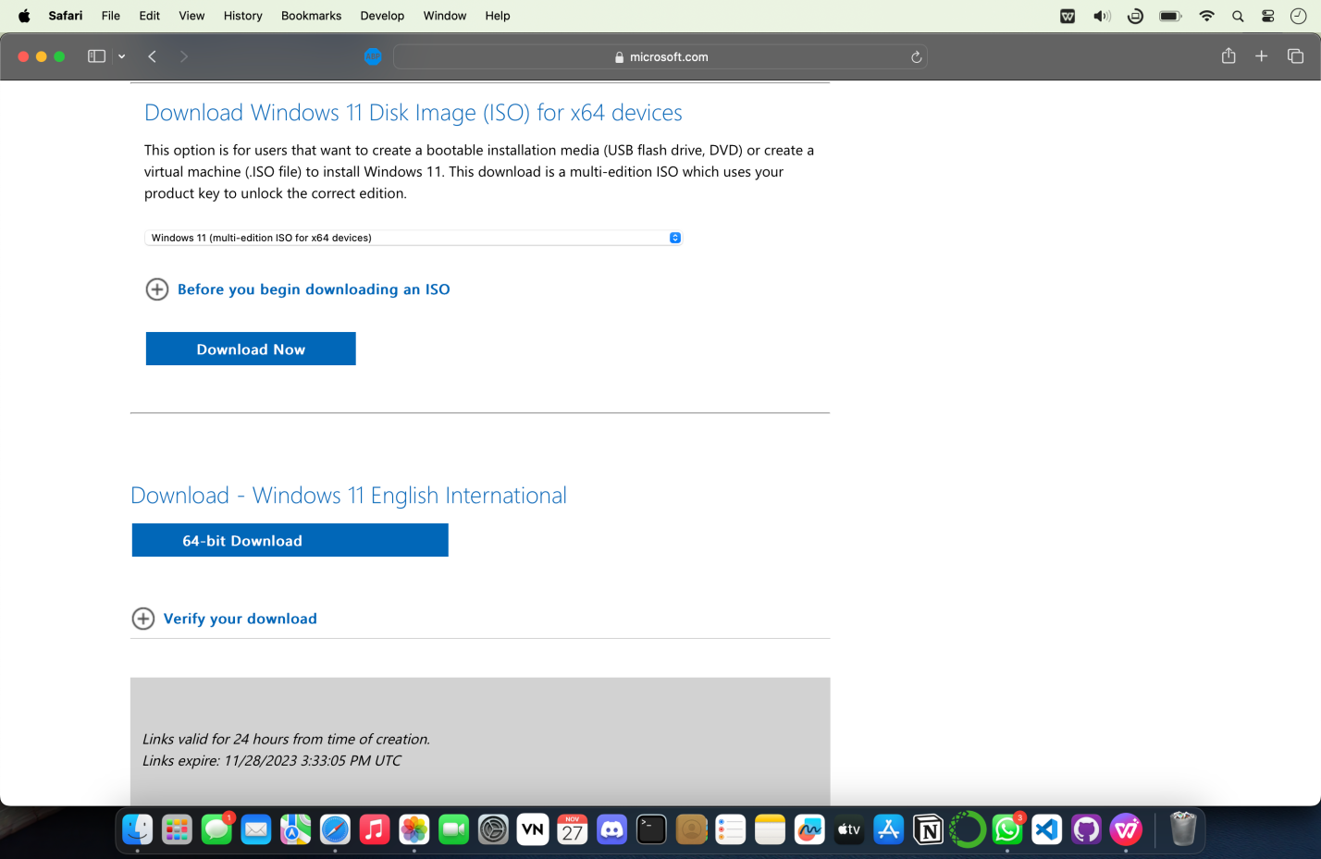

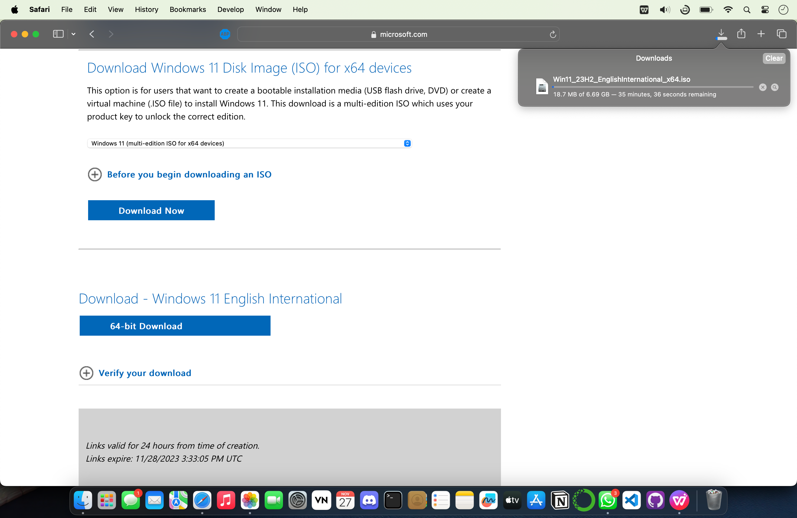

**Step 3:** Create a New VM

- Open VirtualBox or VMware Fusion.

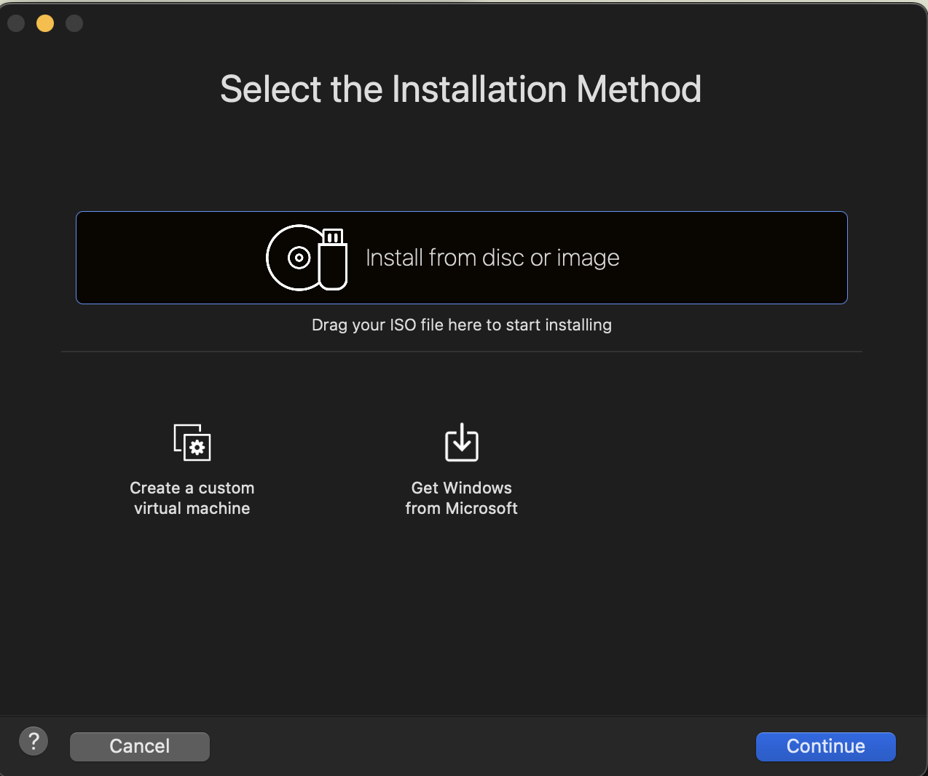

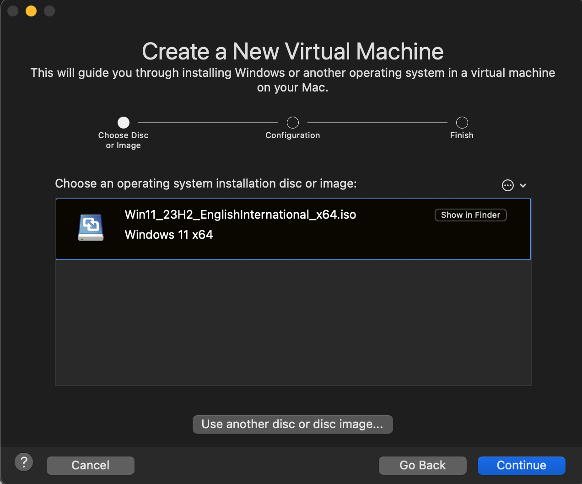

- Create a new virtual machine using the software's interface.

- Name the VM.

- Select the type and version of the guest OS.

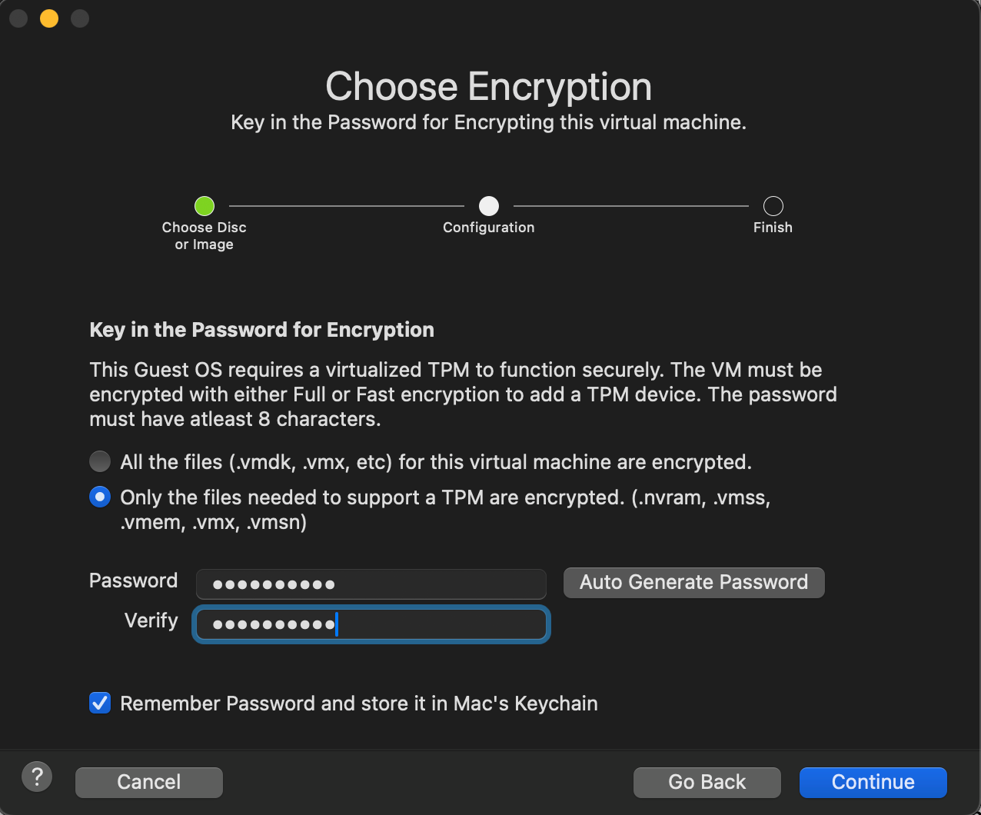

- Allocate memory (RAM) and storage for the VM.

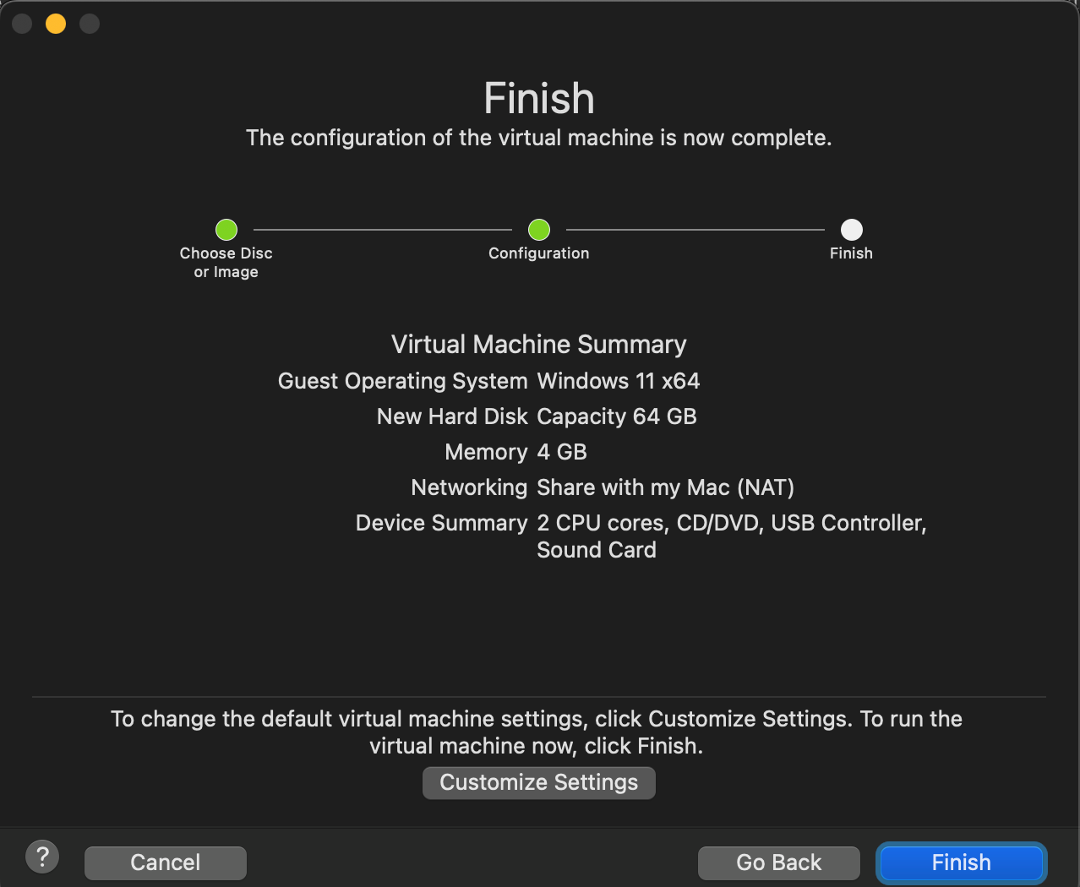

**Step 4:** Configure VM Settings

- Adjust settings like network configurations, display, and additional hardware settings as required.

- Attach the downloaded guest OS ISO file to the virtual optical drive.

**Step 5:** Install Guest OS

- Start the VM and boot from the attached ISO file.

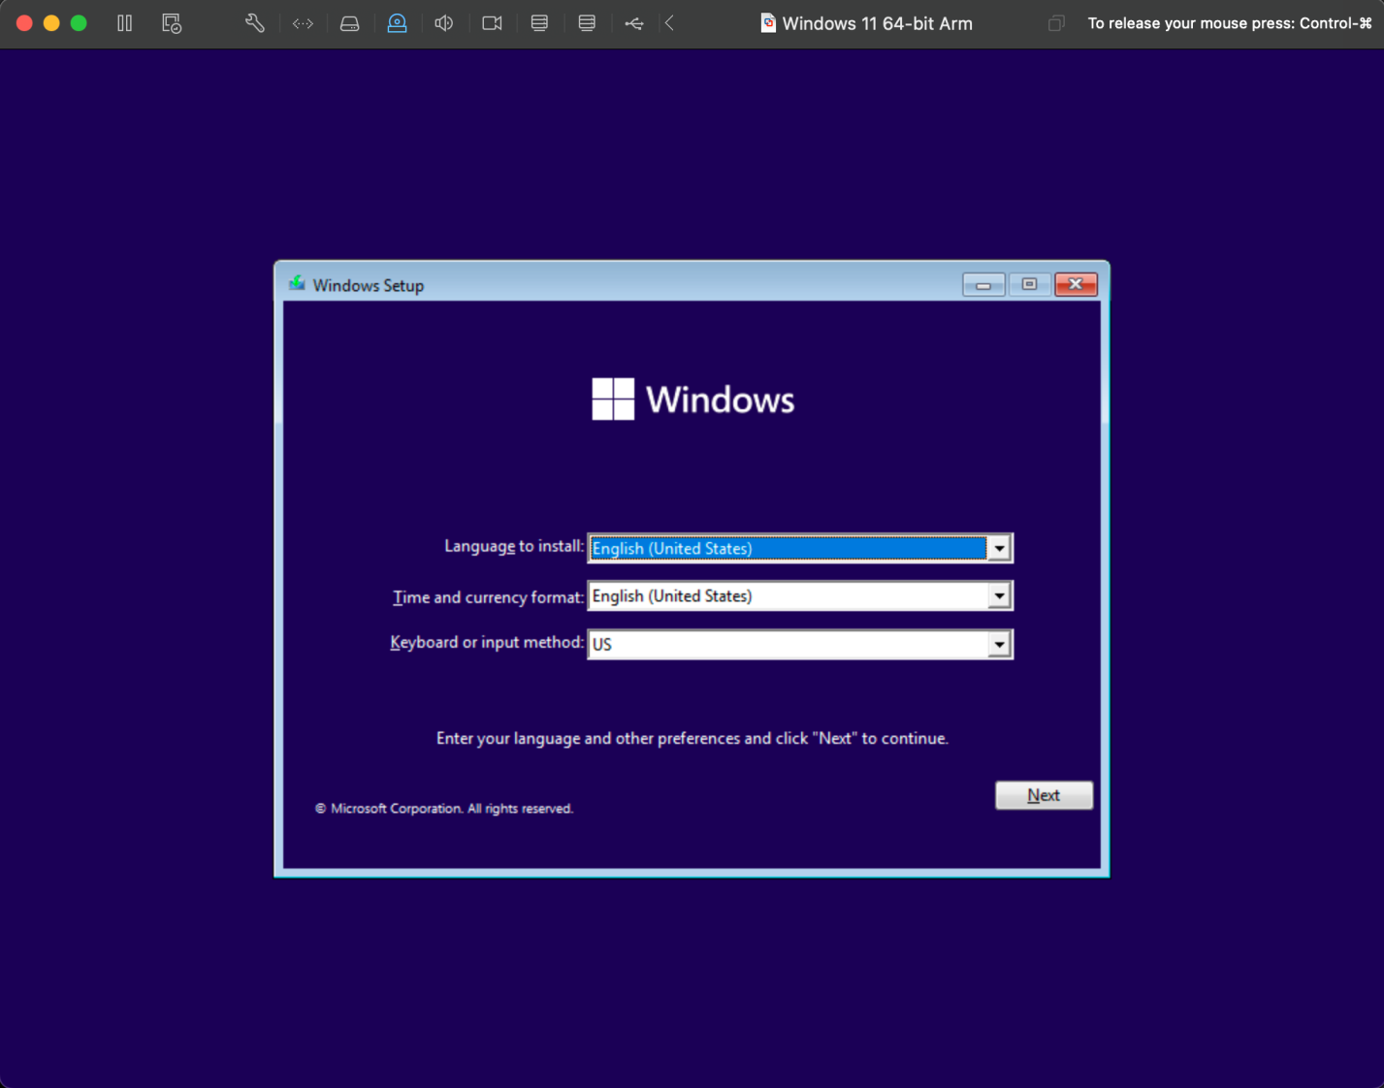

- Follow the installation prompts to install the guest OS within the VM.

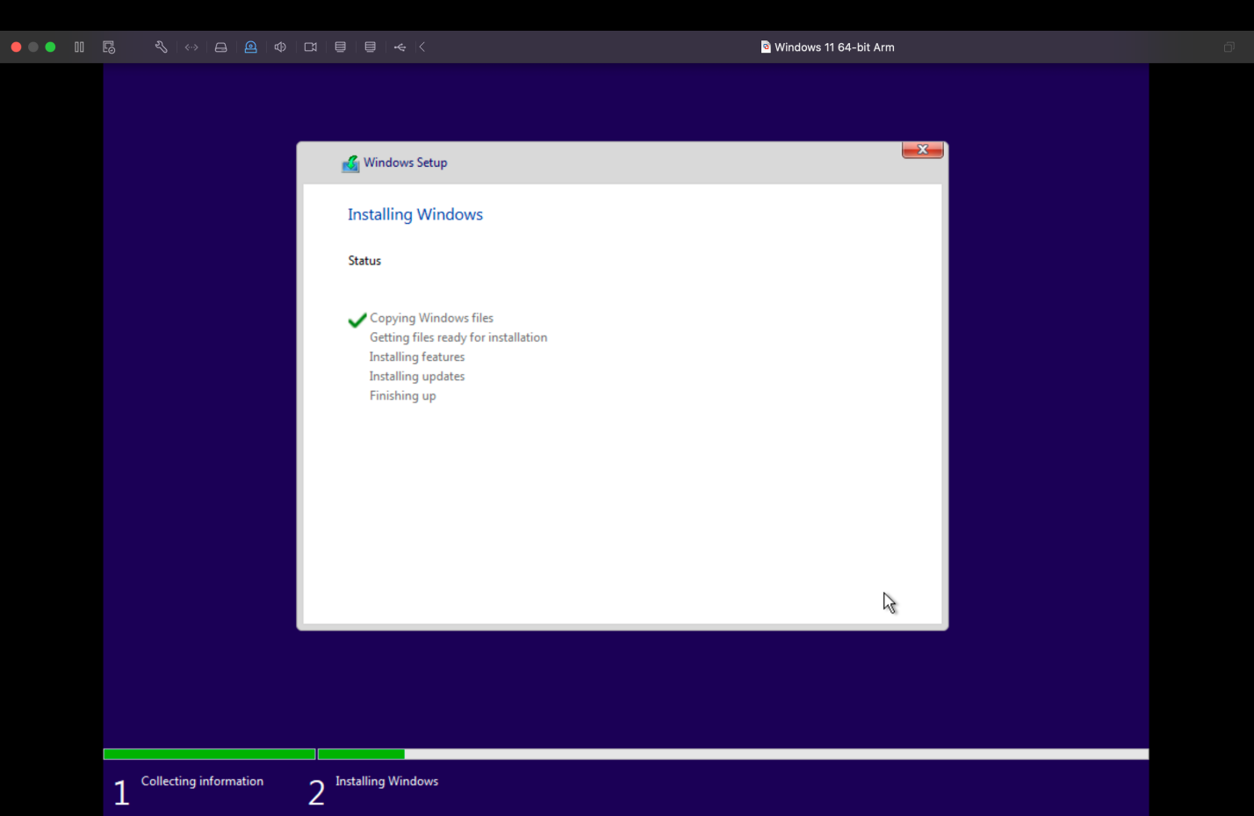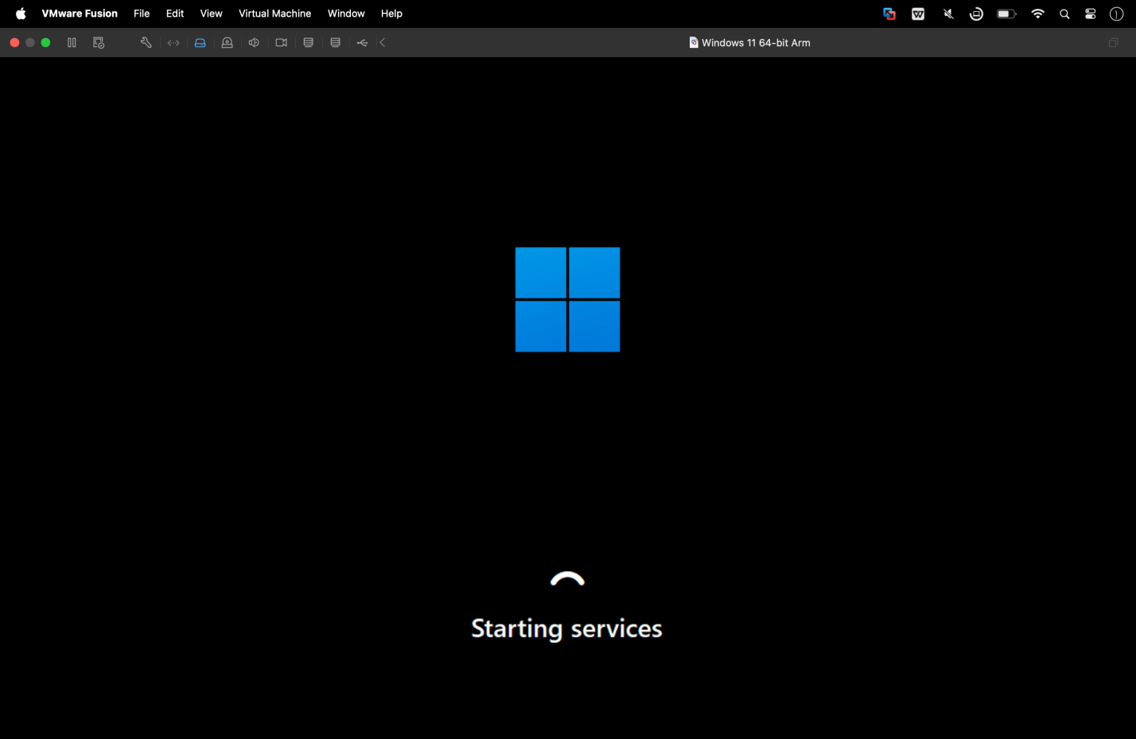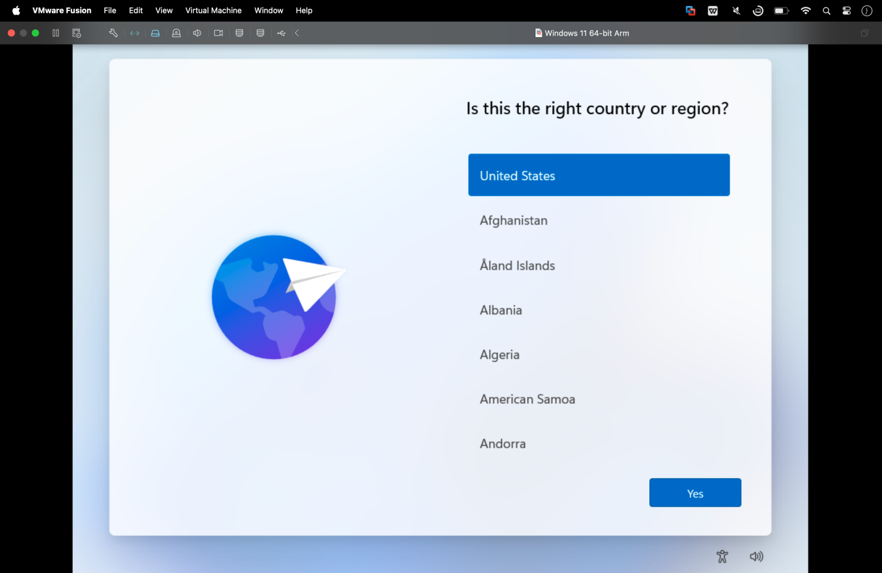

**Step 6:** Complete Installation

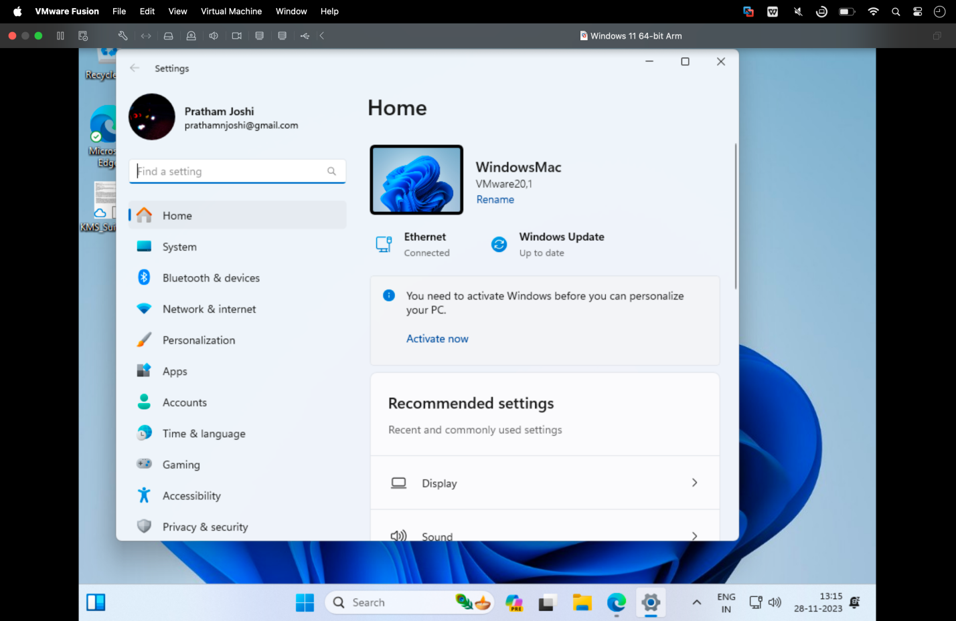

- Eject the ISO file from the virtual optical drive after the guest OS installation is complete.

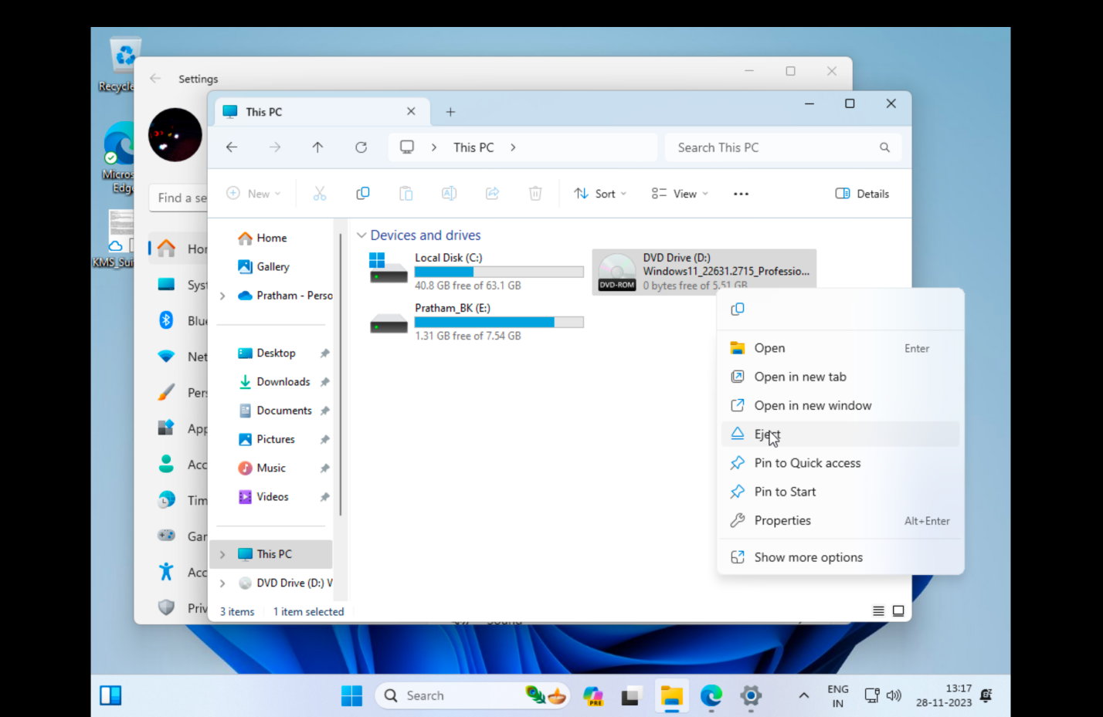

- Restart the VM and configure any additional settings within the guest OS.

**Conclusion:**

Successfully set up and configured a virtual machine with a guest operating system on a macOS environment using VirtualBox or VMware Fusion. This experiment illustrated the process of creating a virtual environment and installing a guest OS, allowing for testing and running different operating systems on a single machine.